Board of Directors Annual Meeting

Wednesday, June 19, 2019, 11:00AM
Mirror Lake Inn, Lake Placid, New York

Agenda
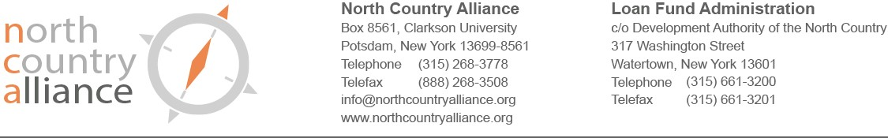
10:45 to 11:00AM | Guest Arrivals & Networking
11:00 to 11:30AM | Annual Meeting  - Call to Order/Roll Call  - Minutes: 6/20/18 meeting  - Re-Appointment of Board Members – Resolution 19-01  - Election of 2018 – 2019 Officers – Resolution 19-02  - Review of NCA Financial Condition
11:30 to 12:00PM | Regular Business Meeting
12:00 to 12:30PM | Lunch Buffet & Networking
12:30 – 1:15PM | Informational Program - Panel Discussion:
“How community development is shifting in the North Country”
Panel:
Matthew Miller, Director of Community Development, City of Plattsburgh
Reg Schweitzer, Deputy Director, Neighbors of Watertown
Andrea Smith, Director of Planning and Development, City of Ogdensburg

Q&A
1:15 – 1:30PM | Concluding Comments and Adjournment

Next Annual Meeting June 17, 2020 at 11:00AM

Board of Directors Regular Meeting

Wednesday, June 19, 2019, 11:30AM – 12:00 PM
Mirror Lake Inn, Lake Placid, New York

Agenda

- Call to Order/Roll Call
- Minutes: 5/15/19 meeting
- President’s Report
- Treasurer’s Report
- Committee Reports
  - Loan Review Committee
- Portfolio Report
- Recent LRC Business
    - Corporate To Be Formed - Solsberry's Bar and Grill
- Loan Sponsorship and Process
- Communications and Membership Committee
- Education and Outreach Committee
- Audit/Finance Committee
- Governance Committee
- Nominating Committee
- Old Business
- New Business
- Adjourn

Next meeting July 17, 2019 at 11:00AM via AccuConference

