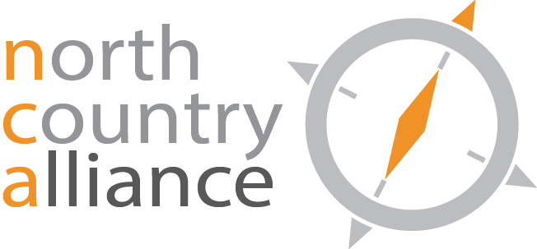

NCA Education and Outreach Committee
AGENDA
January 31, 2020
Conference call: 315-661-3250 or 1-888-823-3347, ID #1351, PIN#944

- 2020 Executive Budget/NCA Legislative Agenda
- Meetings w/elected officials

